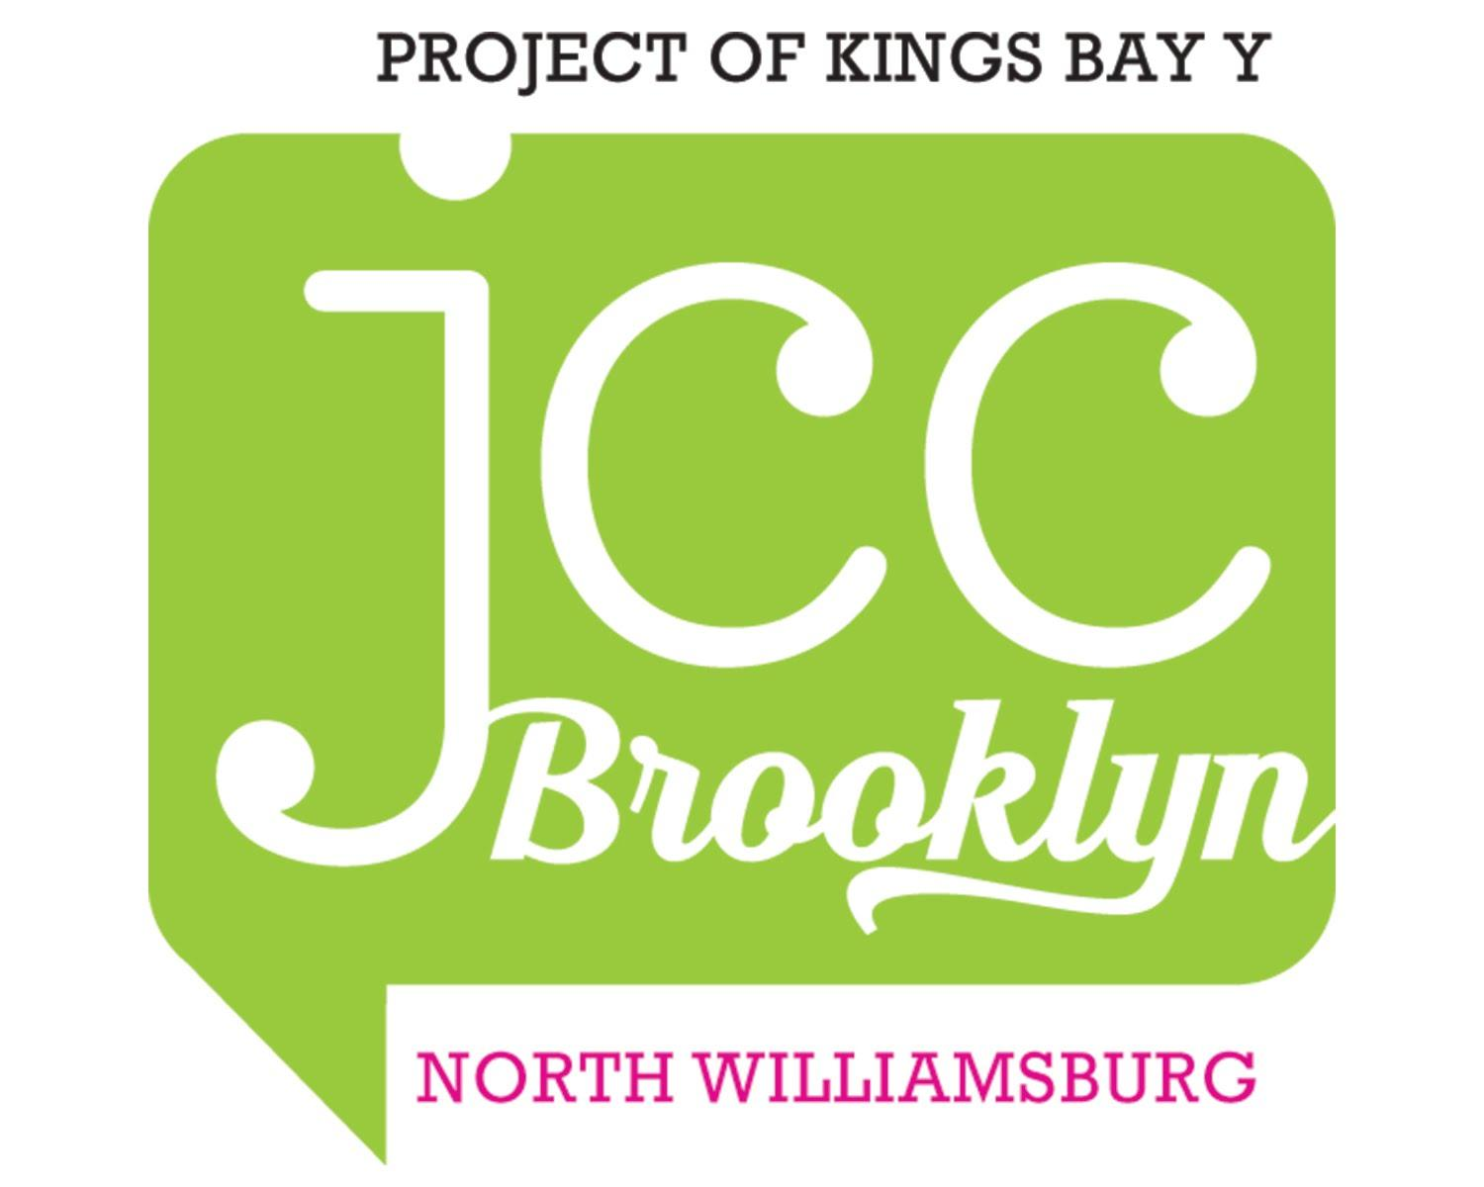

PARENT HANDBOOK
2020-2021

Contents

Welcome to JCC Brooklyn North Williamsburg 3
Required Paperwork 3
Educational Philosophy 3
Jewish Life (Applies to our 2’s and 3’s classes) 4
JCC Brooklyn’s B’rit Kehillah -
Commitment to Respectful Communal Behavior 4
2020-21 School Calendar (as of July 2020) 5
Your Child's First Days at School 7
Phase-In 7
The School Day 9
A Typical Day Might Be 10
Arrival and Departure 11
Parents and Our Community 12
Class Parents 12
Parent Committee 12
Visitors and Special Guests 12
Conferences 12
Support for Students with Special Needs 13
Behavior Management Policy 13
Clothing and Cubby Items 14
Bringing Toys to School 15
Snacks, Lunch and Food Allergies 15
Birthdays 16
Health and Illness 17
Safety and Emergencies 18
Emergency Cards 18
Illness or Injury to A Child 18
Missing Child 18
Evacuation of the Building 18

Welcome to JCC Brooklyn North Williamsburg
We are very pleased that you have chosen our program for your child! Drawing inspiration from Jewish values and culture, we aim to nurture the growth of the whole child in a caring, loving environment. We are looking forward to a rewarding journey together as your child grows as a unique person and a cherished member of our school community.
In order for us to ensure a smooth and effective program, the JCC Brooklyn North Williamsburg Early Childhood Program has compiled the following policies and procedures for parents. We ask for your full cooperation and support by reading and complying with these policies.

Required Paperwork
The following forms and conditions must be met before beginning the school year:
- Financial obligations as agreed to in the JCC Brooklyn/Kings Bay YM-YWHA Contract must be met in full.
- An up-to-date medical form with a full immunization record must be on file. JCC Brooklyn North Williamsburg cannot accept students that are not fully vaccinated!
- Completed emergency card (updated each year).
- Pick up/drop off form
- COVID Form(s)

Educational Philosophy
JCC Brooklyn North Williamsburg is a loving and caring community that embraces all families. We are dedicated to providing our students with a learning environment that nurtures their growth, curiosity, and self-esteem. Our aim is to provide opportunities for children to develop a lifelong passion for learning, to get to know and love themselves as individuals and as members of a caring, cooperative learning community.
We are a progressive school grounded in the philosophy that children learn best through play. Our lively, hands-on curriculum is developed through direct observation of students' interests and individual needs. Through explorations both indoors and outside of our classrooms, we engage children’s curiosity, imagination, and their five senses. In partnership with families, we strive to provide opportunities for each child to develop cognitively, physically, socially, and emotionally at a rate that is most appropriate for him or her.

Jewish Life (Applies to our 2’s and 3’s classes)
JCC Brooklyn is a pluralistic Jewish Community Center located in three physical sites (Clinton Hill, Windsor Terrace, and North Williamsburg), as well as in pop-up spaces. We are inspired by Jewish values and ideas, and we welcome all families regardless of background.
A joyful introduction to Jewish life, culture, and holidays is part of each child's experience at JCC Brooklyn North Williamsburg. Children become familiar with songs, customs, and stories to expand their knowledge of holidays and Jewish values. The joy of Shabbat is shared by our classrooms together each Friday (parents always welcome!), and we learn about and celebrate Jewish holidays and customs throughout the school year.
Children of all ethnic and religious backgrounds are welcome to enroll, and differences in their backgrounds are recognized and respected. While Christmas, Easter, Halloween, and Valentine's Day (as well as other non-Jewish holidays) are not celebrated at school, please be assured that a child's mention of any home celebration is always a welcome topic in the classroom and will be treated with respect and interest.

JCC Brooklyn’s B’rit Kehillah -

Commitment to Respectful Communal Behavior
JCC Brooklyn is a pluralistic Jewish Community Center inspired by Jewish values and ideas that welcomes all families regardless of background. This b’rit (Hebrew for sacred agreement) establishes each individual’s commitment to maintaining a school and a community environment grounded in mutual respect and a sense of personal responsibility.
As a member of the JCC Brooklyn community, I affirm that I will:
- Treat all others with kavod (honor and respect) in recognition of each individual’s dignity and potential;
- Communicate my thoughts in a courteous, timely, and considerate manner and respond similarly to others’ communications;
- Refrain from any behavior that could be construed as sexually harassing, demeaning, hurtful, bullying, or inappropriate.
I understand that JCC Brooklyn reserves the right to exclude any individual who fails to adhere to these standards of behavior in any interaction with staff, parents, or other members of the community.

2020-21 School Calendar (as of July 2020)
JCC Brooklyn North Williamsburg 2019-2020 School Calendar
2’s class 8:30-12:00 or 3:00
3’s classes 8:40-12:00 or 3:10
Pre-K/UPK 8:50-3:20

Date | Event | Additional Details
Tuesday, September 8 and Wednesday, September 9 | Classroom Visits with Teachers- ZOOM | Teachers will reach out in late August to schedule
Wednesday, September 9 | Parent Curriculum Night- ZOOM  - 2’s class: 5pm-6pm  - 3’s class: 6pm-7pm  - UPK class: 7pm-8pm | Attendance is mandatory for at least one parent/caregiver per family
Thursday, September 10 | FIRST DAY OF SCHOOL!  Phase-In Begins-  - 2’s class: 8:30am - 10am, Group 1  10:30am - 12pm, Group 2  - 3’s class: 8:30am - 11am, Group 1  12:30pm - 3pm, Group 2  - UPK class: 8:40am - 11am, Group 1  12:30pm - 2:50pm, Group 2 | Teachers will provide individual class schedules in August
Friday, September 11 | Phase-In Continues:  - 2’s & 3’s class: 8:30am - 12pm,  half day friends  8:30am - 1pm, full day friends with lunch  - UPK class: 8:40am - 12pm, all children
Monday, September 14 | All classes have phased in  - Early bird begins 8am - 8:30am, prior registration required  - Aftercare begins 3pm - 6 pm, prior registration required | Drop off/Pick up Schedule  2’s: 8:30am - 3pm  3’s: 8:40am - 3:10pm  UPK: 8:50am - 3:20pm
Monday, September 28 | Yom Kippur – School Closed
Monday, October 12 | Columbus Day – School Closed
Tuesday, November 3 | Election Day – School Closed  Parent Teacher Conferences 9am-7pm | Teachers will reach out to schedule
Monday, November 11 | Veterans Day – School Closed
Thursday & Friday,  November 26 & 27 | Thanksgiving Break – School Closed
Thursday, December 24 –  Friday, January 1 | Winter Recess – School Closed
Monday, January 4, 2020 | School Resumes
Monday, January 18 | MLK Jr. Day – School Closed
Monday, February 15 –  Friday, February 19 | Mid-Winter Recess – School Closed | *Optional minicamp Tuesday- Friday
Friday, March 5 | Parent Teacher Conferences 9am-7pm  School Closed | Teachers will reach out to schedule
Thursday March 29 to Friday April 2 | Spring Recess and Passover – School Closed | *Optional minicamp
Monday, May 31 | School Closed for Memorial Day
Friday, June 25 | LAST DAY OF SCHOOL – 12pm Dismissal
*Mini Camps are offered during some school closures with sufficient pre-registration (10 or more students).
Additional fees apply.
Early Bird and After Care Hours are available. Please consult the Extended Hours Registration and Tuition Forms for more details or visit our website at: jcc-brooklyn.org/north-williamsburg/programs/afterschool/
Register online for Toddler and Preschool Summer Programs at:
jcc-brooklyn.org/north-williamsburg/summer-camp/
jcc-brooklyn.org/north-williamsburg/programs/0-5/parents_as_partners/#overview

Your Child's First Days at School
Starting the school year is a big step for a child. Adjusting to new places, people, and routines is a process of developing trust in their teachers and the school environment. Each year support from parents and caregivers is an integral part of the process.
Our policy for all students is that the adjustment period (or “Phase-In” period) each year is a gradual one. We ask that a parent or a caregiver plan to stay with their child in school for as long as the teachers and director, along with the parent, determine it necessary. We have found through experience that a slow, gradual separation sets up parents, teachers, and (most importantly) children for a successful school year. However due to COVID-19 parents will not be in the classroom and will be asked to stay close by school so we can easily reach you if your child is having a difficult time.

Phase-In
Your child's first days at school are the Phase-In period. The length of acclimating to school depends on your child's age group, class schedule, and individual needs. This gradual beginning gives each child a chance to get to know his or her teachers, the classroom, its routines, and to feel comfortable in their new group setting in an atmosphere of trust. We understand that Phase-In can be inconvenient for families, and we appreciate your cooperation during this period.
Please note that Phase-In begins BEFORE the beginning of the school year, during a special classroom visit that will be scheduled by your child's teachers. This year all classroom visits with parents will be done via zoom. During this classroom visit, your child will be the focus, and you should save any questions you have for our Parent Night, which will also take place during this week via zoom.

Date | UPK - Blue Room - Phase-In Schedule
Tuesday, September 8th and Wednesday, September 9th | Classroom Visits with Teachers via zoom  Your teachers will reach out to you in late August to schedule this meeting.
Wednesday, September 9th | Parent Curriculum Night @ 7pm-8pm via zoom
Thursday, September 10th | Phase-In, Group 1: 8:40-11:00  Phase-In, Group 2: 12:30-2:50  Teachers will provide individual class schedules in late August
Friday, September 11th | Phase-In: 8:40-12:00, all children
Monday, September 14th | Full Day 8:50-3:20  Early Bird and After Care begins

Date | 3’s - Green Room - Phase-In Schedule
Tuesday, September 8th and Wednesday, September 9th | Classroom Visits with Teachers via zoom. Your teachers will reach out to you in late August to schedule this meeting.
Wednesday, September 9th | . Parent Curriculum Night @ 6-7pm via zoom
Thursday, September 10th | Phase-In, Group 1: 8:30-11:00  Phase-In, Group 2: 12:30-3:00
Friday, September 11th | Phase-In: 8:30-12:00, half day friends  12:30-3 full day friends with lunch
Monday, September 14th | Half day friends leave at 12pm, full day friends leave at 3pm.  Early Bird and After Care begins
Date | 2’s - Orange Room - Phase-In Schedule
Tuesday, September 8th and Wednesday, September 9th | Classroom Visits with Teachers via zoom. Your teachers will reach out to you in late August to schedule this meeting.
Wednesday, September 9th | . Parent Curriculum Night @ 5pm-6pm via zoom
Thursday, September 10th | Phase-In, Group 1: 8:30-10:00  Phase-In, Group 2: 10:30-12:00
Friday, September 11th | Phase-In: 8:30-12:00, half day friends  8:30-1pm, full day friends with lunch
Monday, September 14th | Half day friends leave at 12pm, full day friends leave at 3pm.  Early Bird and After Care begins

The School Day
To meet the growing needs and interests of our preschoolers, the daily program includes a variety of activities including: Art activities, dramatic play, outdoor/gym time, games, water/sand play, blocks, music, dance, manipulative play, circle/story time, science explorations, age appropriate math and literacy experiences.
A Typical Day Might Be
8:30 -50) - 9:30 - FREE PLAY/WORK TIME - which allows for the use of materials and equipment in the
room, work on special projects, cooking, art, etc.

9:30 - 10:00 - CIRCLE TIME - during which the group can gather to discuss plans for the day, read a story,
sing a song, or share talk about experiences at home or in school.

10:00 - 10:30 - ART, LIBRARY or GYM

10:30 - 10:45 - SNACK

10:45 - 11:30 - PLAYGROUND

11:30 - 12:00 - CIRCLE TIME or short WORK TIME

12:00 - DISMISSAL - for half day students

12:00 - 12:45 - LUNCH

12:45 - 1:45 - REST or QUIET PLAY

1:45 - 2:00 - SNACK

2:00 - 2:45 - FREE PLAY/WORK TIME

2:45 - 3:00 - GOODBYE CIRCLE

3:00 - DISMISSAL - for Full-Day students

Arrival and Departure
Children should be brought to school and picked-up promptly. Due to COVID, drop off will be in front of the school where the director or teacher will be taking your child's temperature while you sign them in. At this time we highly urge you not to bring strollers unless its an emergency.
If someone new will be picking up your child, be sure to notify our staff. YOUR CHILD WILL NOT BE RELEASED TO SOMEONE OTHER THAN A USUAL CAREGIVER WITHOUT WRITTEN CONSENT. If your plans for the day change, please call the school to make arrangements. Please make verbal contact with your child’s teacher at drop-off and let us know about anything unusual regarding his or her routine, mood, or physical status.
If you are running late please let the office know so we can notify the teachers!

Parents and Our Community
Parent presence and involvement is a crucial part of our school community! There will be many opportunities throughout the school year for parents to assist in different capacities with school and community events, such as holiday celebrations. Parents are always welcome in the classroom at any time. If you or someone in your family would like to volunteer time/activity space/resources please speak with your child’s teachers.
Class Parents
Your teachers will request that one or more of the parents in your class function as Class Parents. Class Parents are helpful to teachers with communication to other parents about general upcoming events, needs in the classroom, and times when volunteers may be required.

Parent Committee
The JCC Brooklyn North Williamsburg Parent Committee is a working group of parent volunteers and staff dedicated to advancing the quality of the Preschool Program. The committee organizes, helps to plan, and participates in a variety of school and community-wide events and fundraisers.

Visitors and Special Guests
Visitors are welcome. Sometimes an out-of-town relative comes to visit, and your child is eager to show off his/her school. We would be pleased to plan a visit if you notify us in advance.
In addition, we welcome guests to participate in special events, birthdays, and to volunteer their time in the classroom. These visits should be arranged in advance with your child's teachers.

Conferences
Parent-teacher conferences this year will be via zoom and are scheduled twice a year, once in the fall and once in the spring. These conferences are for parents only and provide an opportunity to sit down with your child's teachers to discuss progress, interests, friendships, and goals for your child. If you wish to discuss something of immediate importance, please be sure to call or email for an appointment. We are ALWAYS happy to arrange a time to discuss your child with you.
Please DO NOT engage the teachers in conversation when class is in session, especially during arrival and dismissal times. Their responsibility at this time is to the children.

Support for Students with Special Needs
Children learn and grow in their own individual ways. We strive to make the classroom a place of exploration, challenge, and success for all of our students. In some cases, an evaluation and/or services are recommended. Services may include but are not limited to: Speech Therapy, Occupational Therapy, Physical Therapy, or the assistance of a SEIT (Special Education Itinerant Teacher).
If a child in our school receives special education services, an educator from the team is selected to be the "team leader." In this role, they will schedule meetings for all parents and pertinent educators, ensure that communication is maintained, and monitor progress toward educational goals. Please provide your child's teachers and the school director with any documentation you have (IEP, etc) to support us in specifically tailoring the classroom activities to your child's individual needs and strengths.

Behavior Management Policy
Young children are in the process of learning how to communicate with others and to express their feelings. Often behaviors that are viewed as undesirable are a communication from a child about something that they want or need. Regarding behavior management, our goal is for children to develop increasing self-control, self-confidence, and to form satisfying relationships with peers and other members of the community. To this end, teachers will focus on positive behaviors and reinforce these as often as possible. Each classroom environment and routine will be age-appropriate in order to foster a joyful and nurturing experience for each child, which is conducive to positive behaviors. Along with positive reinforcement, teachers will redirect children as needed to help them make good choices. Teachers and children together will create class rules (e.g. keep hands and feet to our own bodies) in order to make the classroom environment safe and respectful for all. This process of creating and referring to class rules helps children to understand the expectations for behavior.
Along with the help of parents, we strive to understand a child's experience of being in school, and we will, to the extent possible, modify the classroom to accommodate the children’s needs. Inappropriate behaviors will be responded to firmly and consistently with the aim of the child developing increasing self-control. Children will be treated with love, care, and respect at all times.
A child will be directed to a “rest-spot” when teachers determine that a child needs to "take a break." Examples of times when a child needs to take a break include engaging in aggressive behaviors and not responding to redirection by teachers. The rest-spot is not punitive; instead, it is a cozy quiet place that provides a moment to take a breath and reset. Children will be in the rest-spot for a maximum of one minute per year of age. Before rejoining the group, a teacher will speak with the child to make sure that the child understands the behavior expected of him/her.
If a child's behavior disrupts the functioning of the class, the child may be removed from the class until she/he is ready to rejoin the group in a productive way. In this case, the child will always be in the company of another teacher or staff person.
Parents will be notified in cases of behaviors such as hitting and biting. Parents of recipients of hitting and biting will also be notified of the incident, with consideration for the confidentiality of involved families. Teachers will communicate with parents in case of disruptive or harmful behaviors and together we will develop a strategy to address these behaviors. If needed, parents may be advised to have a specialist observe a child for possible support services. If, after our school has made efforts to accommodate a child, the child's behavior continues to disrupt class or the child continues to harm other children, the child will be asked to leave the school.
Children will always be treated with respect. Any form of corporal punishment, abusive language, withholding or threatening to withhold food or access to the bathroom, shaming of child, isolating a child, or other punitive actions are prohibited.

Clothing and Cubby Items
We cannot overemphasize the importance of sending your child to school in simple, washable clothing. It is inevitable that clothing gets dirty when children play. It is also extremely important that fastenings be simple enough to encourage your child's independence in toileting and in dressing.
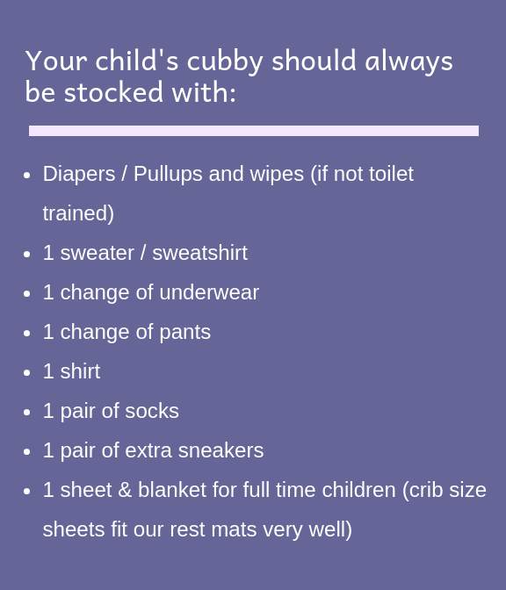

Bringing Toys to School
If your child needs to bring her/his favorite toy to school, we do not object. Some children need the comfort of a special toy from home to help them make a comfortable adjustment to school or to help them nap comfortably.
If your child asks to bring toys to school which are not essential to his/her adjustment, we ask you to dissuade him/her since problems sometimes occur; other children may want to play with the toy, and toys can get lost, misplaced, or broken at school.
Costumes, as well as guns and war toys, are not permitted in school. For very young children, the line between reality and pretend can be blurred, and we find that these toys encourage reenactment of "action" media which can lead to play that is too rough. A young child can have trouble following the routines of the day while dressed in a costume, as well.

Snacks, Lunch, and Food Allergies

Birthdays

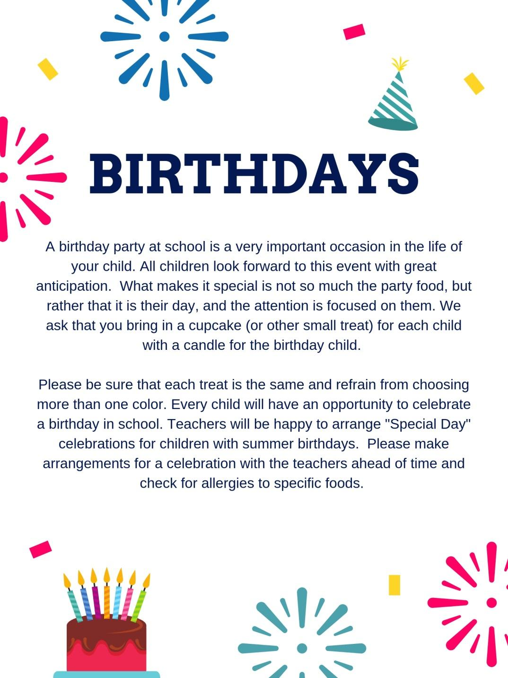

Health and Illness
Every child is required to have a physical examination by their own physician within one calendar year of the start of school each year.
If your child's temperature reads 100.4 or over during drop off, they will be sent home and we urge that you have them seen by their pediatrician and tested for COVID. They will be allowed back when they are fever free for 24 hours without meds or with a doctor's note.
A Department of Health Form is provided to each family in their enrollment packet. This must be filled out by your child's doctor and returned prior to the beginning of school. YOUR CHILD CANNOT BE ADMITTED ON THE FIRST DAY OF SCHOOL WITHOUT A FULLY COMPLETED HEALTH FORM.
- Your child should be kept home if they show any sign of illness and should come back to school only when they can participate in the full program of their class, both indoors and outdoors. We have no provisions for caring for children who are sick. Please notify the school as soon as possible if your child will not be in attendance because of an illness.
- If your child has had an illness lasting more than one week, a doctor's written consent is required for your child to return to school.
- When your child has been ill with a fever, they may not return to school until they are fever-free (without fever-reducing medicine) for at least 24 hours.
- In case of contagious disease or exposure to contagion (i.e. chickenpox, pink eye, stomach virus, lice), parents are asked to notify the school immediately, even if this occurs during vacation periods within the school year.
- If your child has lice (or nits), they will not be allowed to remain in school. Teachers will do periodic head checks as prevention, but it is expected that a close eye is kept on the situation at home.
- If your child has a rash of unknown origin, they must be seen by a physician. A doctor’s note saying that the child is not contagious is required in order for the child to return to school.
- A doctor’s note is required before a child who has been suffering from diarrhea returns to school.
- If your child has ANY viral infection (all viral infections are highly contagious), they will not allowed to come to school until a doctor has cleared it safe for them to return
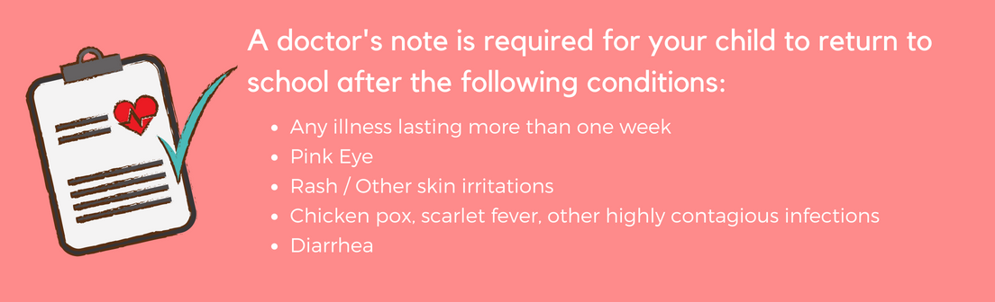
The school will notify you if a teacher observes that your child has become ill during school hours and cannot fully participate in class activities. You will then be expected to arrange for your child to be picked up and promptly taken home.
Parents will be notified by the school if a child in the class has a contagious disease.

Safety and Emergencies
We take the utmost care to prevent emergencies from occurring. However, in the rare event of an emergency, it is important that our families know what to expect.

Emergency Cards
Each family will be asked to complete emergency cards. In the event of any emergency or illness, you will be called. If you cannot be reached, the emergency contacts indicated on your cards will be called and asked to come pick-up your child. Bearing that in mind, be sure that your emergency contacts are close enough to respond quickly to an emergency.

Illness or Injury to A Child
Parents will be contacted to bring a child home promptly if emergency medical care is not deemed necessary. A sick or injured child will be transported to the hospital for emergency care if required. If it is necessary to call 911 for emergency personnel, parents will be called immediately afterward once help is on the way.

Missing Child
Our teachers take tremendous care that no child is ever left unattended. To prevent any confusion, children are not released to their caregivers or parents until they have been signed-out on the class sign-out form. In the event that it is realized a child is missing in the building, we will initiate lockdown procedures until the child is located.
During class trips, teachers constantly count (and recount) the children in their groups. If it is ever discovered that a child is missing on a trip, children will be re-grouped, and the immediate area searched for no longer than 3 minutes before calling 911 and alerting appropriate site authorities. The school director and parents will be called immediately after 911. The group will remain with one teacher while chaperones and staff conduct a search until the child is found.

Evacuation of the Building
Our school conducts fire drills during the school year in order to ensure that our staff and students know how to evacuate safely and quickly. In the event of an actual emergency, staff will evacuate children as planned, moving them down the block, past the school building. In cold weather, if possible, children will enter the lobby of one of our neighboring buildings. In the event that it is not safe to stay in the immediate vicinity, JCC Brooklyn North Williamsburg has an arrangement with P.S. 84 (located at 250 Berry Street) to allow our students to wait there until they can be picked up by a caregiver or parent. In this event, families would be notified after the evacuation was safely completed.

