PARENT HANDBOOK
2020-2021

Contents

Welcome to JCC Brooklyn…………………………………………………………………………………………………………. 3
a Project of Kings Bay Y…………………………………………………………………………………………………………… 3
Required Paperwork 3
Educational Philosophy 3
Jewish Life 3
Sample 2019-20 School Calendar (as of August 2019) 4
Your Child's First Days at School 6
Phase In 7
Arrival and Departure 8
Visitors and Special Guests 9
Parents and Our Community 9
Clothing and Cubby Items 9
Bringing Toys to School 9
Birthdays 10
Snacks, Lunch and Food All 11
Conferences 11
Support for Students with Special Needs 11
Health and Illness 12
Biting Policy 13
Behavior Management Policy 13
Safety and Emergencies 14
Emergency Cards 14
Illness or Injury to A Child 14
Missing Child 14
Evacuation of the Building 15

Welcome to JCC Brooklyn

a Project of Kings Bay Y to JCC Brooklyn Clinton Hill
We are very pleased that you have chosen our program for your child! Drawing inspiration from Jewish values and culture, we aim to nurture the growth of the whole child in a caring, loving environment. We are looking forward to a rewarding journey together as your child grows as a unique person and a cherished member of our school community.
In order for us to ensure a smooth and effective program the JCC Brooklyn Early Childhood Program has compiled the following policies and procedures for parents. We ask for your full cooperation and support by reading and complying with these policies.

Required Paperwork
The following forms and conditions must be met before beginning the school year:
- Financial obligations as agreed to in the JCC Brooklyn/Kings Bay YM-YWHA Contract must be met in full.
- An up-to-date medical form with a full immunization record must be on file. JCC Brooklyn cannot accept students that are not fully vaccinated.

Educational Philosophy
JCC Brooklyn is a loving and caring community that embraces all families. We are dedicated to providing our students with a learning environment that nurtures their growth, curiosity and self-esteem. Our aim is to provide opportunities for children to develop a lifelong passion for learning, to get to know and love themselves as individuals and as members of a caring, cooperative learning community.
We are a progressive school grounded in the philosophy that children learn best through play. Our lively, hands-on curriculum is developed through direct observation of students' interests and individual needs. Through explorations both indoors and outside of our classrooms we engage children’s curiosity, imagination and their five senses. In partnership with families, we strive to provide opportunities for each child to develop cognitively, physically, socially and emotionally at a rate that is most appropriate for him or her.

Jewish Life
JCC Brooklyn is a pluralistic Jewish Community Center located in three physical sites (Windsor Terrace, North Williamsburg and Clinton Hill) as well as in pop-up spaces. We are inspired by Jewish values and ideas and we welcome all families regardless of background.
A joyful introduction to Jewish life, culture and holidays is part of each child's experience at JCC Brooklyn. Children become familiar with songs, customs and stories to expand their knowledge of holidays and Jewish values. The joy of Shabbat is shared by our classrooms together each Friday (parents always welcome!) and we learn about and celebrate Jewish holidays and customs throughout the school year.
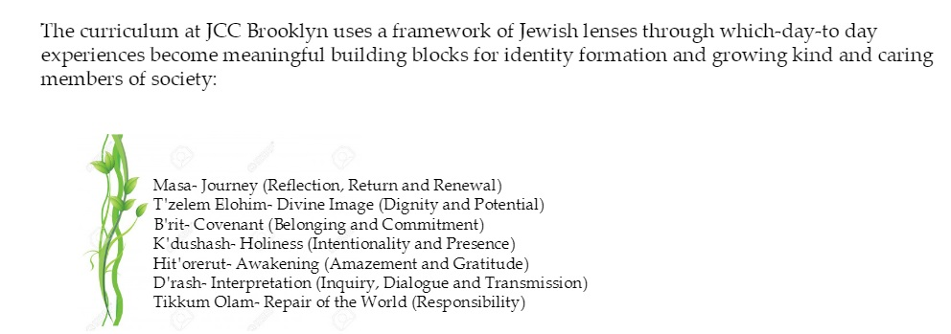
Children of all ethnic and religious backgrounds are welcome to enroll, and differences in their backgrounds are recognized and respected. While Christmas, Easter, Halloween and Valentine's Day (as well as other non-Jewish holidays) are not celebrated at school, please be assured that a child's mention of any home celebration is always a welcome topic in the classroom and will be treated with respect and interest.

Sample 2019-20 School Calendar (as of August 2019)

Date | Event | Additional Details
Tuesday, September 3 and Wednesday, September 4 | Classroom Visits with Teachers | Teachers will reach out in late August to schedule
Wednesday, September 4 | Parent Orientation Night 6:00-7:00pm | Attendance is mandatory for at least one parent/caregiver per family
Thursday, September 5 | FIRST DAY OF SCHOOL! Phase-In Begins:  ALL Students attend 8:30-10:00am OR 10:30am-12:00pm with a parent or caregiver | Teachers will provide individual class schedules in August
Friday, September 6 | Phase-In Continues:  ONLY students with Friday schedules attend 8:30am-12:00pm  - New Students – parent or caregiver must remain in the building  - Returning Students – parent or caregiver on-call
Monday, September 9 | Phase-In Continues:  ONLY students with Monday schedules attend  - Half-Day Students Regular Schedule (8:30-12:00)  - NEW Full-Day Students 8:30-12:30 (with lunch)  - RETURNING Full-Day Students 8:30-3:00 (lunch & nap) Early drop off Students Regular Schedule (8:00-8:30)  Aftercare begins for Returning Students ONLY (prior registration required)
Tuesday, September 10 | Phase-In Continues:  ONLY students with Tuesday schedules attend  - Early drop off for Students (8:00-8:30)  - Half-Day Students Regular Schedule (8:30-12:00)  - ALL Full-Day Students 8:30-3:00  Aftercare for Returning Students ONLY (prior registration required)
Wednesday, September 11 | Last day of adults in classroom (as needed)  Aftercare for New AND Returning Students (prior registration required)
Thursday, September 12 | All Classes have Phased In
Sunday, September 22 | Community-wide Rosh Hashanah Celebration | All are welcome!
Monday, September 30 and Tuesday, October 1 | Rosh Hashanah (2 days) – School Closed
Wednesday, October 9 | Yom Kippur – School Closed
Monday, October 14 | Columbus Day – School Closed
Tuesday, November 5 | Election Day – School Closed  Parent Teacher Conferences 9am-7pm
Monday, November 11 | Veterans Day – School Closed
Thursday & Friday,  November 28 & 29 | Thanksgiving Break – School Closed
Sunday, December 15 | Community Wide Chanukah Celebration | All Are Welcome!
Monday, December 24 –  Wednesday, January 1 | Winter Recess – School Closed | Optional minicamp [12/24, 26, 27, 30, 31]
Thursday, January 2, 2020 | School Resumes
Monday, January 20 | MLK Jr. Day – School Closed
Monday, February 17 –  Friday, February 21 | Mid-Winter Recess – School Closed | Optional minicamp =February 18, 19, 20, 21
Wednesday, March 4 | Parent Teacher Conferences 9am-7pm  School Closed
Sunday, March 8 | Community Wide Purim Celebration | All Are Welcome!
Thursday, April 9 –  Friday, April 17 | Spring Recess and Passover – School Closed | Optional minicamp
Monday, May 25 | School Closed for Memorial Day
Friday, June 26 | LAST DAY OF SCHOOL – 12pm Dismissal
Mini Camps are offered during some school closures with sufficient pre-registration (10 or more students).
Additional fees apply.
Register online for Infant/Toddler and Preschool Summer Programs (June 29 – August 21, 2020) at jcc-brooklyn.org
Monthly family events [Shabbat Dinners, Parent Committee meetings, etc] TBD

Your Child's First Days at School
Starting the school year is a big step for a child. Adjusting to new places, people and routines is a process of developing trust in their teachers and the school environment. Each year support from parents and caregivers is an integral part of the process.
Our policy for all students is that the adjustment period (or “Phase In” period) each year is a gradual one. We ask that a parent or caregiver plan to stay with their child in school for as long as the teachers and director, along with the parent, determine it is necessary. We have found through experience that a slow, gradual separation sets up parents, teachers, and (most importantly) children for a successful school year.
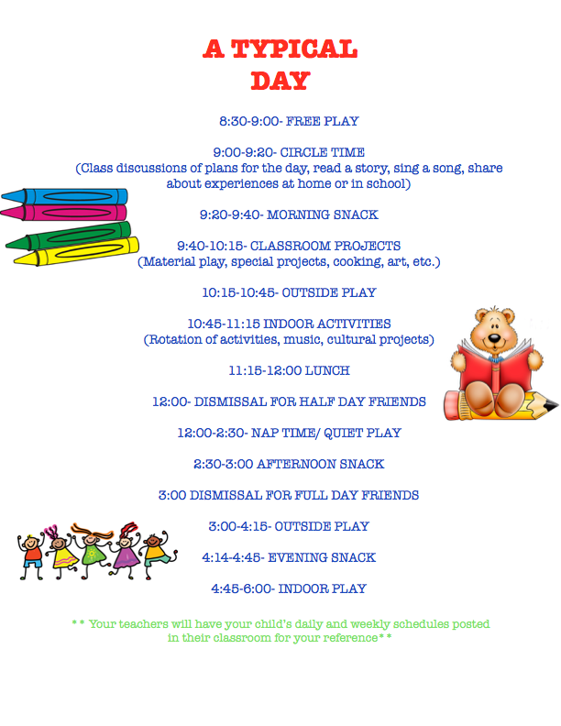

Phase In
Your child's first days at school are the Phase In period. The length of acclimating to school depends on your child's age group, class schedule and individual needs. This gradual beginning gives each child a chance to get to know his or her teachers, the classroom and its routines, and to feel comfortable in their new group setting in an atmosphere of trust. We understand that Phase-In can be inconvenient for families and we appreciate your cooperation during this period.
Please note that Phase In begins BEFORE the beginning of the school year, during a special classroom visit that will be scheduled by your child's teachers. During this classroom visit your child will be the focus and you should save any questions you have for our Parent Night, which will also take place during this week.
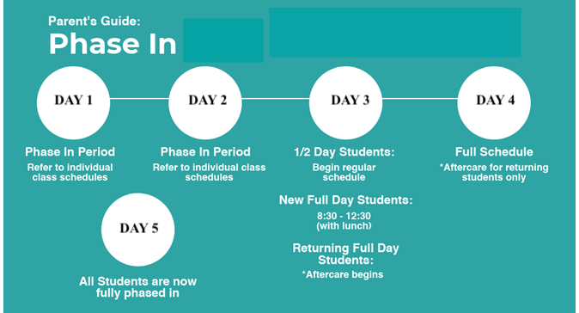
Sample phase in schedule:

Arrival and Departure
Children should be brought to school and picked up promptly. Please bring your child to the classroom and pick her or him up from there unless you are participating in our After Care programs. Be sure to make verbal contact with a teacher at drop off and to sign your child out at pick up times. If someone new will be picking up your child, be sure to notify our staff. YOUR CHILD WILL NOT BE RELEASED TO SOMEONE OTHER THAN A USUAL CAREGIVER WITHOUT WRITTEN CONSENT. If your plans for the day change, please call the school to make arrangements.
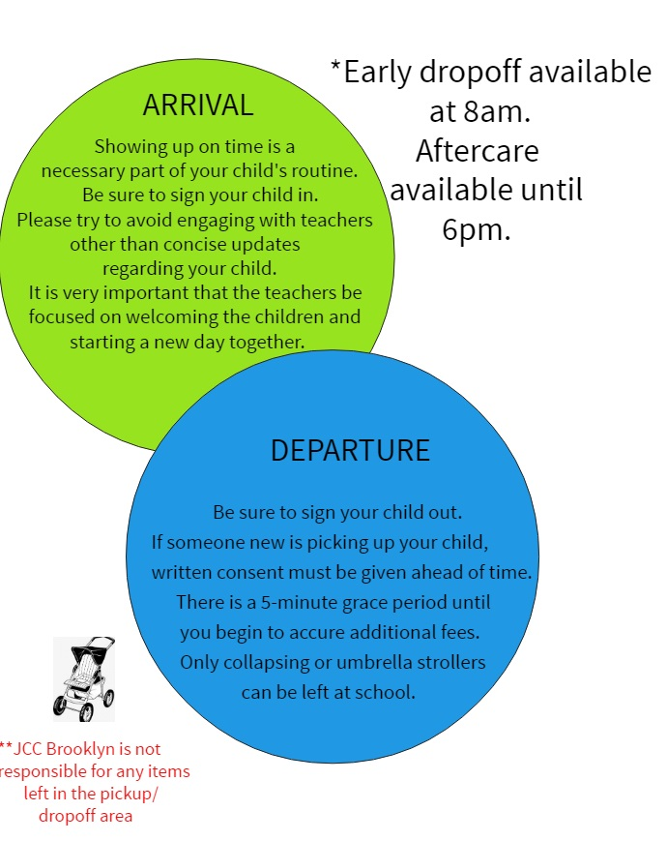

Visitors and Special Guests
Visitors are welcome. Sometimes an out-of-town relative comes to visit and your child is anxious to show off his/her school. We would be pleased to plan a visit if you notify us in advance.
In addition, we welcome guests to participate in special events, birthdays, and to volunteer their time in the classroom. These visits should be arranged in advance with your child's teacher.

Parents and Our Community
Parent presence and involvement is a crucial part of our school community! There will be many opportunities throughout the school year for parents to assist in different capacities with school and community events such as holiday celebrations. Parents are always welcome in the classroom at any time. If you or someone in your family would like to volunteer time/activity space/resources please speak with your child’s teacher.

Clothing and Cubby Items
We cannot overemphasize the importance of sending your child to school in simple, washable clothing. It is inevitable that clothing gets dirty when children play. It is also extremely important that fastenings be simple enough to encourage your child's independence in toileting and dressing.
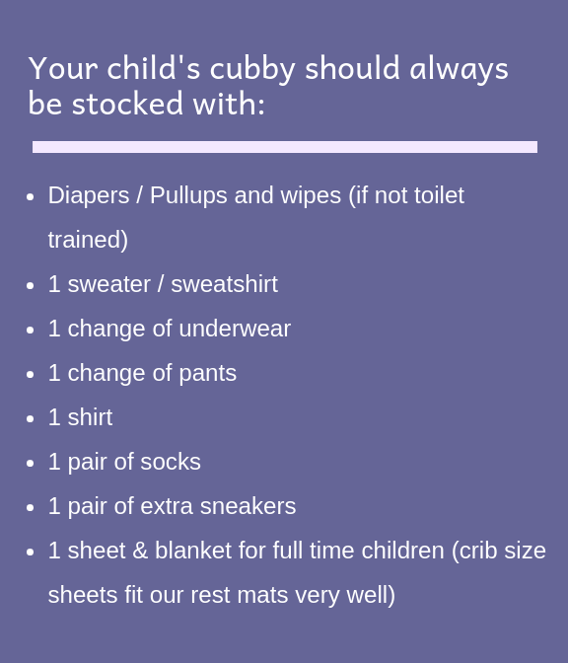

ALL ITEMS MUST BE CLEARLY LABELED so they may be easily identified.

When soiled clothing or sheets and blankets are sent home, please launder and send back replacements on the next school day. Full day students' sheets and blankets will be sent home periodically.

Bringing Toys to School
If your child needs to bring her/his favorite toy to school, we do not object. Some children need the comfort of a special toy from home to help them make a comfortable adjustment to school or to help them nap comfortably.
If your child asks to bring toys to school which are not essential to his/her adjustment, we ask you to dissuade him/her since problems sometimes occur: other children may want to play with the toy, and toys can get lost, misplaced or broken at school.
Costumes, as well as guns and war toys are not permitted in school. For very young children the line between reality and pretend can be blurred and we find that these toys encourage reenactment of "action" media which can lead to play that is too rough. A young child can have trouble following the routines of the day while dressed in a costume, as well.

Birthdays

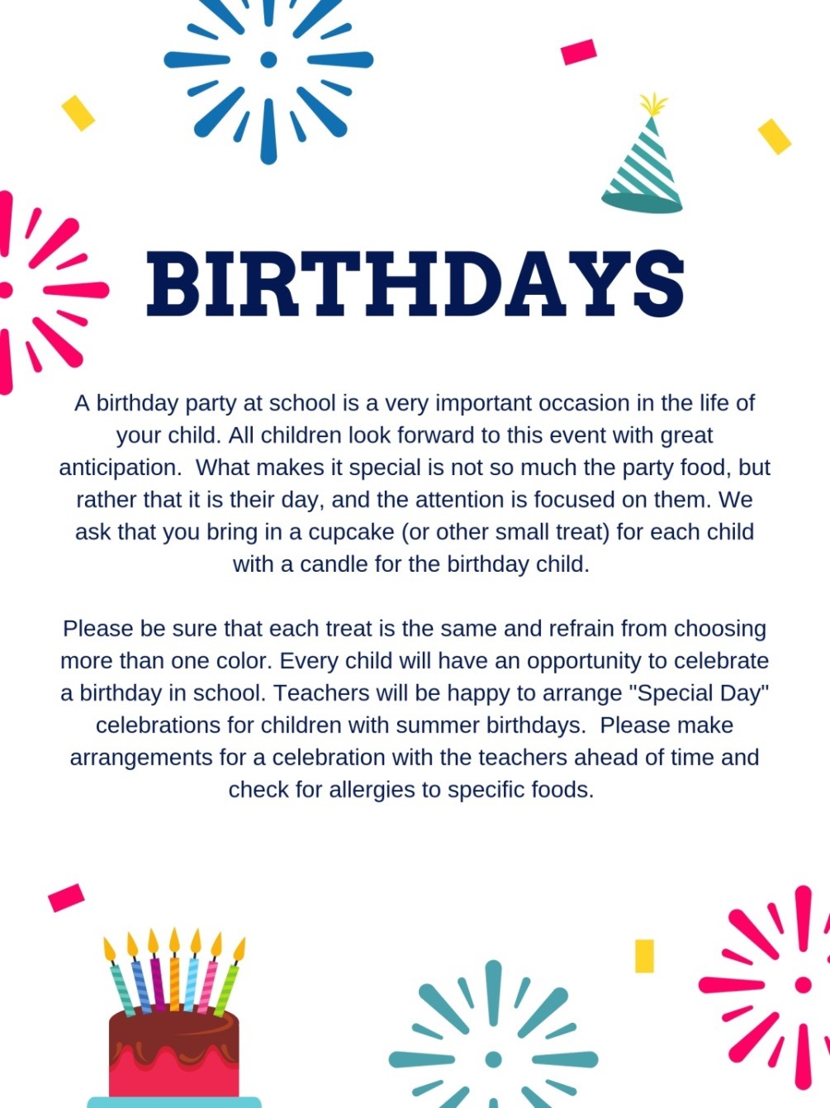

Snacks, Lunch and Food All

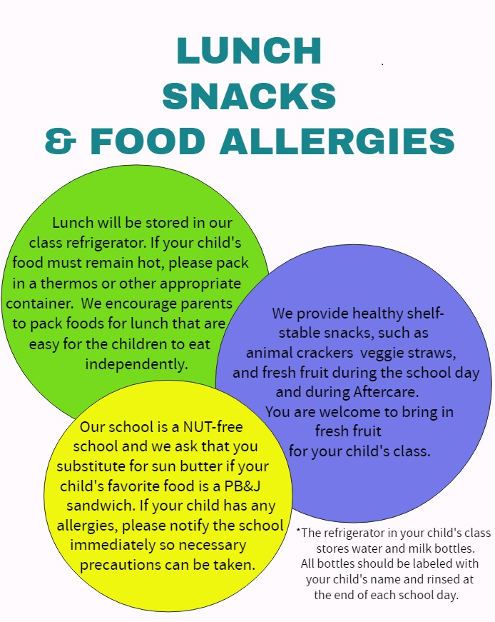
Conferences
Parent-teacher conferences are scheduled twice a year, once in the fall and once in the spring. These conferences are for parents only and provide an opportunity to sit down with your child's teachers to discuss progress, interests, friendships and goals for your child. If you wish to discuss something of immediate importance, please be sure to call or email for an appointment. We are ALWAYS happy to arrange the time to discuss your child with you.
Please DO NOT engage the teachers in conversation when class is in session, especially during arrival and dismissal times. Their responsibility at this time is to the children.

Support for Students with Special Needs
Children learn and grow in their own individual ways. We strive to make the classroom a place of exploration, challenge and success for all of our students. In some cases, Special Education evaluations and/or services are recommended. Services may include, but are not limited to: Speech Therapy, Occupational Therapy, Physical Therapy or the assistance of a SEIT (Special Education Itinerant Teacher).
If a child in our school receives special education services, an educator from the team is selected to be the "team leader". In this role they will schedule meetings for all parents and pertinent educators, ensure that communication is maintained, and monitor progress toward educational goals. Please provide your child's teachers and the school director with any documentation you have (IEP, etc) to support us in specifically tailoring the classroom activities to your child's individual needs and strengths.

Health and Illness
Every child is required to have a physical examination by their own physician within one calendar year of the start of school each year.
A Department of Health Form is provided to each family in their enrollment packet. This must be filled out by your child's doctor and returned prior to the beginning of school. YOUR CHILD CONNOT BE ADMITTED ON THE FIRST DAY OF SCHOOL WITHOUT A FULLY COMPLETED HEALTH FORM.
- Your child should be kept home if they show any sign of illness and should come back to school only when they can participate in the full program of their class both indoors and outdoors. We have no provisions for caring for children who are sick. Please notify the school as soon as possible if your child will not be in attendance because of an illness.
- If your child has had an illness lasting more than one week a doctor's written consent is required for your child to return to school.
- When your child has been ill with a fever [100.4 of higher], they may not return to school until they are fever free (without fever-reducing medicine) for at least 24 hours.
- In case of contagious disease or exposure to contagion (i.e. chicken pox, pink eye, stomach virus, lice) parents are asked to notify the school immediately, even if this occurs during vacation periods within the school year. If your child has lice (or nits), they will not be allowed to remain in school. Teachers will do periodic head checks as prevention, but it is expected that a close eye is kept on the situation at home.
- If your child has a rash of unknown origin they must be seen by a physician. A doctor’s note saying that the child is not contagious is required in order for the child to return to school.
A doctor’s note is required before a child who has been suffering from diarrhea returns to school. The school will notify you if a teacher observes that your child has become ill during school hours and cannot fully participate in class activities. You will then be expected to arrange for your child to be picked up and promptly taken home.
Parents will be notified by the school if a child in the class has a contagious disease.

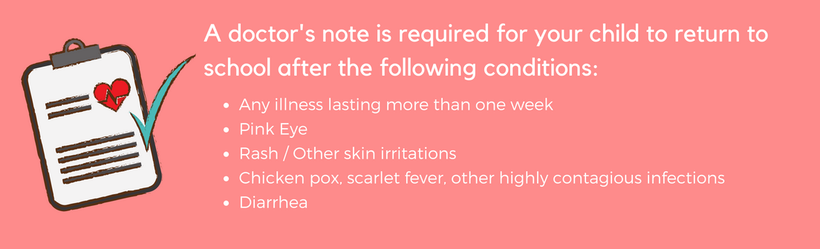

Biting Policy

Biting is a normal stage of development, and frequently occurs in children just on the verge of fluent
language. When it happens, it can be scary and frustrating for everyone involved. It simply means that
a child is going through that particular stage in his or her development. As with all stages that children
go through, biting usually diminishes over time. At the same time, for safety and health concerns, we
take biting seriously. In situations where a child is routinely biting, our staff works with families to
develop a school action plan to reduce biting incidents and help the child work through this stage of
development. When biting happens, our response is to care for and help the child who was bitten, and
then to help the biter learn other behaviors. Our focus is not on punishment of the biting, but on the
effective techniques to address the reasons for biting.

Behavior Management Policy
Young children are in a process of learning how to communicate with others and express their feelings. Often behaviors that are viewed as undesirable are a communication from a child about something that they want or need. Regarding behavior management, our goal is for children to develop increasing self-control, self- confidence, and to form satisfying relationships with peers and other members of the community. To this end, teachers will focus on positive behaviors and reinforce these as often as possible. Each classroom environment and routine will be age-appropriate in order to foster a joyful and nurturing experience for each child, which is conducive to positive behaviors. Along with positive reinforcement, teachers will redirect children as needed to help them make good choices. Teachers and children together will create class rules (e.g. keep hands and feet to our own bodies) in order to make the classroom environment safe and respectful for all. This process of creating and referring to class rules helps children to understand the expectations for behavior.
Along with the help of parents, we strive to understand a child's experience of being in school and we will, to the extent possible, modify the classroom to accommodate the children’s needs. Inappropriate behaviors will be responded to firmly and consistently with the aim of child developing increasing self-control. Children will be treated with love, care and respect at all times.
Child will be directed to a “rest spot” when teachers determine that a child needs to "take a break". Examples of times when a child needs to take a break include engaging in aggressive behaviors and not responding to redirection by teachers. The rest spot is not punitive: instead it is a cozy quiet place that provides a moment to take a breath and reset. Children will be in the rest spot for a maximum of one minute per year of age. Before rejoining the group a teacher will speak with the child to make sure that the child understands the behavior expected of him/her.
If child's behavior disrupts the functioning of the class, the child may be removed from the class until she/he is ready to rejoin the group in a productive way. In this case child will always be in the company of another teacher or staff person.
Parents will be called in case behaviors such as hitting and biting. Parents of recipients of hitting and biting will also be called. Teachers will communicate with parents in case of disruptive or harmful behaviors and together we will develop a strategy to address these behaviors. If needed, parents may be advised to have a specialist observe child for possible support services. If, after our school has made efforts to accommodate a child, the child's behavior continues to disrupt class or the child continues to harm other children the child will be asked to leave the school.
Children will always be treated with respect. Any form of corporal punishment, abusive language, withholding or threatening to withhold food or access to bathroom, shaming of child, isolating child or other punitive actions are prohibited.

Safety and Emergencies
We take the utmost care to prevent emergencies from occurring. However, in the rare event of an emergency it is important that our families know what to expect.

Illness or Injury to A Child
Parents will be contacted to bring a child home promptly if emergency medical care is not deemed necessary. A sick or injured child will be transported to the hospital for emergency care if required. If it is necessary to call 911 for emergency personnel, parents will be called immediately afterward once help is on the way.

Missing Child
Our teachers take tremendous care that no child is ever left unattended. To prevent any confusion, children are not released to their caregivers or parents until they have been signed out on the class clipboard. In the event that is realized a child is missing in the building we will initiate lockdown procedures until the child is located.
During class trips, teachers constantly count (and recount) the children in their groups. If it is ever discovered that a child is missing on a trip, children will be re-grouped and the immediate area searched for no longer than 3 minutes before calling 911 and alerting appropriate site authorities. The school director and parents will be called immediately after 911. The group will remain with one teacher while chaperones and staff conduct a search until the child is found.

Evacuation of the Building
Our school conducts fire drills during the school year in order to ensure that our staff and students know how to evacuate safely and quickly. In the event of an actual emergency, staff will evacuate children as planned moving them down the block past the school building. In cold weather, if possible children will enter the lobby of one of our neighboring buildings. In the event that it is not safe to stay in the immediate vicinity, JCC Brooklyn Windsor Terrace has an arrangement with Sun Dojo (located at 1256 Prospect Avenue) to allow our students to wait there until they can be picked up by a caregiver or parent. In this event, families would be notified after evacuation was safely completed.

