Schedule Options, Enrollment Policies, and Tuition Rates
JCC Brooklyn Clinton Hill Early Childhood Programs
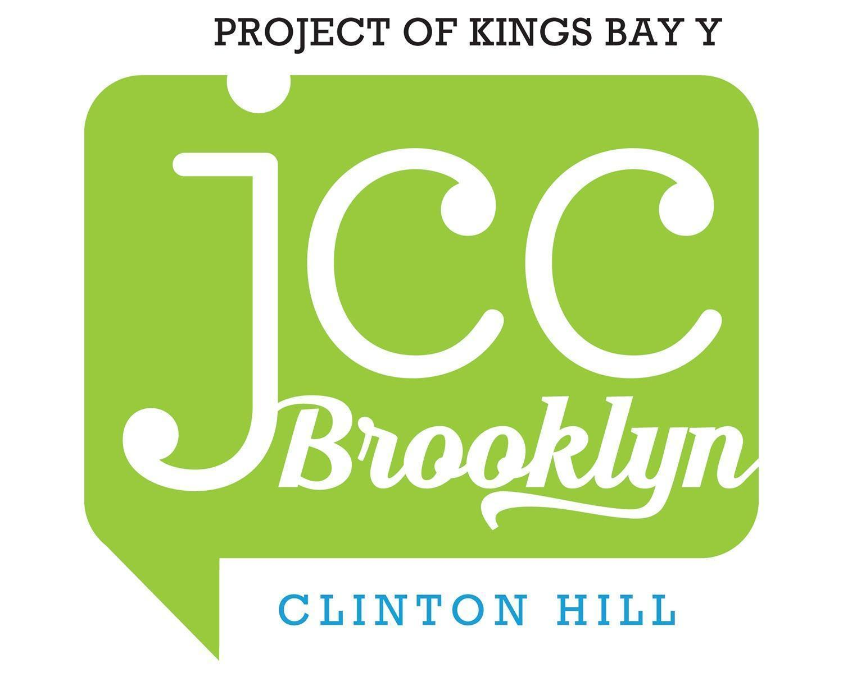
2026-27 School year Registration Dates
(We follow the DOE school year calendar with a few exceptions)
- December 1: Enrollment Begins for Current Students & Siblings
- December 15: Enrollment Begins for New Students
- January 17-February 1: Commencing with 2026-27 School Year Contracts
- February 10: 1st Deposit Due for enrolling 2026-27 School Year families
- March 10: 2nd Deposit Due enrolling 2026-27 School Year families
- Tentative September 10 School Year Begins (Phase-in is September 10 and 11. Regular classes begin on September 14).

Enrollment Policies
- Children who are between 12 and 24 months of age will be enrolled in the Infant-Toddler program.
- Children who are between 2 and 4 years will be enrolled in the Preschool program.
- Transfer between classroom/programs during the school year (September-June) is rare. Transfers will be considered on a case-by-case basis and depend on space availability, current classroom makeup, and the child’s development.
- We maintain an open enrollment policy throughout the year. If a spot becomes available during the school year, parents on the wait list will be notified.
- Applications are not carried over from year to year. If your family declines a spot for the current year, re-application for the following school year is required.
- Families enrolling more than one child will receive a 10% discount in tuition for the child(ren) with the lowest total contracted tuition.
- Tuition deposits are non-refundable and non-transferable.
- Medical forms and immunization records must be complete and current before the start of school.

Registration Information
- In order to be eligible for enrollment, you must submit a completed current registration online for each child.
- During the registration process, the following weekly schedule options are available:
  - 5 Days per Week
  - 3 Days per Week (M/W/F)
  - 2 Days per Week (T/Th)
- Your child’s enrollment is not confirmed until we receive your signed enrollment contract and both parts of your tuition deposit.
- The tuition deposit is equal to two months of tuition (September and June) and will be applied to your total balance. For your convenience, your balance will be charged in monthly installments and is due on or before the first of each month from October through May.
- A $500 activity fee will be charged for the school year and is due with the 1st Tuition Deposit.
- Tentatively, the school year begins on September 10, 2026.
- Registration for Summer 2027 not included in the 2026-27 registration. You are not guaranteed a space in the summer program until you complete Camp registration.

2026-27 Tuition Rates (September-June)
*Tuition rates are for the full 2026-27 school year (September-June) of 10 months unless noted otherwise. For your monthly tuition simply divide your total by 10.
Preschool (Ages 2-4; Birthdate must be 10/15/2022 or earlier) | Half-Day Preschool  (8:30am-12:00pm) | Full Day Preschool  (8:30am-3:00pm)
5 days/week | $19,850.00 | $22,900.00
3 days/week | $14,850.00 | $16,500.00
2 days/week (2s only) | $11,850.00 | $13,500.00

Infant-Toddler (Ages 12-24 months; Birthdate must be 10/15/2024 or earlier) | Half-Day Infant-Toddler  (8:30am-12:00pm) | Full Day Infant-Toddler  (8:30am-3:00pm)
5 days/week | $19,450.00 | $22,450.00
3 days/week | $13,050.00 | $16,000.00
2 days/week | $11,250.00 | $13,000.00

2026-27 School Year Extended Care Options (September-June)
*Prices below are done by year. Monthly, daily, and weekly rates available on request.

 | Early Bird  (8:00-8:30am) | Late Stay  (3:00-6:00pm)
5 Days/week | $2,350.00 | $5,850.00
4 Days/Week | $2,100.00 | $5,650.00
3 Days/week | $1,850.00 | $5,550.00
2 Days/week | $1,350.00 | $5,250.00

