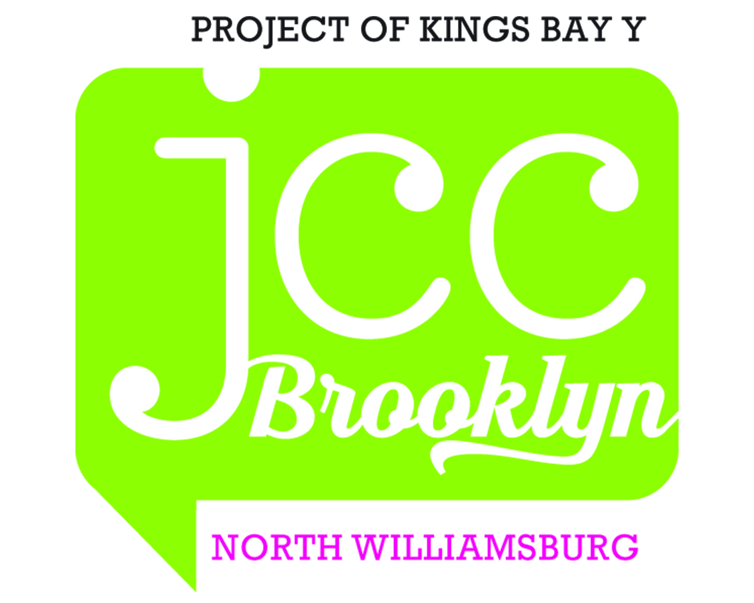 JCC Brooklyn North Williamsburg. 14 Hope Street, Brooklyn, New York 11211 Tel. (718) 407-6388

Recurring Payment Authorization Form

New Delete Change
Schedule your payments to be automatically charged to your credit/debit card or bank account. Just complete and sign this form to get started!

Recurring Payments Will Make Your Life Easier:
- It’s convenient (saving you time and postage)
- Your payment is always on time (even if you’re out of town), eliminating late charges
- You could get Rewards Points for paying your bill by credit/debit card (check with your credit/debit card issuer)

Here’s How Recurring Payments Work:
You authorize regularly scheduled charges to your checking or savings bank account or to your credit/debit card. You will be charged the total amount due for that period. Bank account debit will appear on your bank statement as “ACH Debit” or, if credit card or debit card payment method is selected, you will see a recurring charge to your card. You agree that no prior notification will be provided for recurring payments. A receipt and periodic statement showing open balance will be emailed or mailed to you based on selected preference. If paying via checking account deduction, you may set up a recurring transfer with your banking institution from your savings/money market account to ensure sufficient funds are available.
Please complete the information below:

I _________________________________ authorize Kings Bay Y to charge my credit/debit card ending in __________ or debit my (print full name of paying party)
bank account ending in _______ as indicated below on the 1st day of each month in the amount specified in program

registration document(s) as payment(s) for _______________________________________________________________________.
(print full name of program attendee(s))
I understand that if the above noted payment date falls on a weekend or holiday, the payment may be executed on the next business day.
Billing Address ___________________________________________ City, State, Zip _________________________________

Phone# __________________Alternative Phone#___________________ E-mail_________________________________________
Notification Preference E-mail Mail
In consideration for the goods, products and/or services provided by Kings Bay Y to me or program attendees I designate, I hereby authorize the above named organization to initiate credit and, if necessary, debit entries and adjustments for any credit entries in error to my account as indicated in this authorization form according to the terms outlined herewith. I understand that the above named organization will provide products/services as requested by me from time to time and I agree to pay the purchase price for such products/services, plus any shipping and handling charges, and acknowledge, such amounts shall be collected by electronic debits or deductions by the above named organization. I understand that because this is an electronic transaction, these funds may be withdrawn from my account as soon as the above noted periodic transaction dates. In the case of transaction being rejected for Non Sufficient Funds (NSF), I understand that Kings Bay Y may, at its discretion, attempt to process the charge again within 30 days, and agree to an additional $20 charge for each attempt returned NSF which will be initiated as a separate transaction from the authorized recurring payment. I acknowledge that the origination of ACH transactions to my account must comply with the provisions of U.S. law. This payment authorization is for the type of bill indicated above. I certify that I am an authorized user of this bank account/debit card/credit card (as applicable), and that I will not dispute the scheduled payments with my financial institution/credit card company, provided the transactions correspond to the terms of our agreement. This authorization is to remain in full force and effect until Kings Bay Y has received written notification from me of its termination in such time, and in such manner as to afford Kings Bay Y and Financial Institution a reasonable opportunity to act on it. I may only revoke this authorization by contacting Kings Bay Y directly at the address and phone number listed above, and only in the case that I return the goods, product and/or service provided to me by Kings Bay Y pursuant to their particular return policy in effect on the date this authorization is granted.
SIGNATURE DATE
(Account Owner Signature)

Please retain top portion for record keeping (KBYPA12)

Charge my Credit Card Charge my Debit Card
Account Type: Visa MasterCard Discover American Express Debit Card
Our payment agent charges 3.5% fee for credit card transactions. Kings Bay Y does not receive any portion of this fee
Cardholder Name _________________________________________________
Cardholder Billing Address ____________________________________________________________________
Credit /Debit Card # |  |  |  |  |  |  |  |  |  |  |  |  |  |  |  |  |  |  | Exp. Date
 |  |  |  |  |  |  |  |  |  |  |  |  |  |  |  |  |  |  |  | /
 |  |  |  |  |  |  |  |  |  |  |  |  |  |  |  |  |  | Mo. |  |  | Yr.
CVV (3 digit number on back of Visa/MasterCard or 4 digit number on front of American Express Card) ______
Debit my bank Account* at the depository Financial Institution named below:
*This form MUST be accompanied by a Printed Voided Check or Bank Letter*
Account Type: Checking Savings
Name on Acct _______________________________
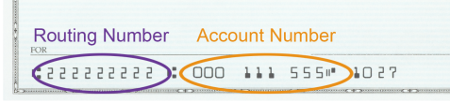
Account Number _______________________________
Bank Routing # (9 digits) _________________________
Bank Name _______________________________
Bank Address, Bank City/State ___________________________________________________________

Note: Destroy this account information stub and/or voided checks, bank letters, card imprints by crosscut or strip-cut shredding, pulping, burning or equivalent

