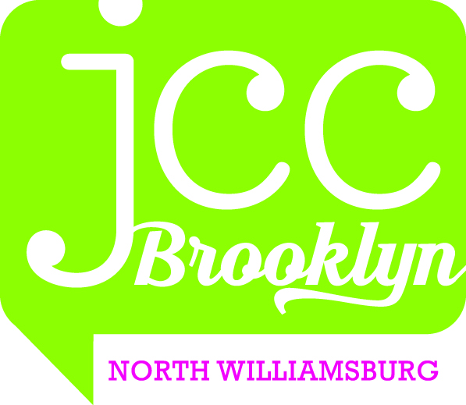

A CONSENT TO PHOTOGRAPH, FILM, OR VIDEOTAPE

Child’s Name_________________________________________________________________

I hereby consent to the participation in interviews, the use of quotes, and the taking of photographs, movies or video tape of the Student named above by the JCC Brooklyn at North Williamsburg.

I also grant to the JCC Brooklyn at North Williamsburg the right to edit, use and reuse said products for nonprofit purposes including use in print, on the Internet, and all others forms of media.

I also hereby release the JCC Brooklyn at North Williamsburg and its agents and employees from all claims, demands and liabilities whatsoever in connection with above.

Signature of Parent___________________________________________________________

Parent’s Name Printed________________________________________________________

Date_________________________________________________________________________



